Module # | 252301-001-00-KM-06
NQF Level | 4
Notional hours | 30
Credit(s) | 3
Curriculum Code | 252301001
Qualification Title | Occupational Certificate: Cloud Administrator
Development  Quality Partner | MICT SETA
Occupation or Specialization | Cloud Administrator
Associated Occupation | Computer Network and Systems Engineer

Fundamentals of Cloud Computing Platforms

NQF Level 4, Credits 3

Learner Guide
CONTACT INFORMATION:
Name
Contact Address
Telephone (H)
Telephone (W)
Facsimile
Cellular
E-mail

Note to the learner
This Learner Guide provides a comprehensive overview of the module. It is designed to improve the skills and knowledge of learners, and thus enabling them to effectively and efficiently complete specific tasks.

Purpose:
The main focus of the learning in this knowledge module is to build an understanding of cloud computing principles, concepts, definitions and cloud computing deployment

Entry Requirements:
NQF 3

PROVIDER ACCREDITATION REQUIREMENTS FOR THE MODULE:

Physical Requirements:
The provider must have lesson plans and structured learning material or provide learners with access to structured learning material that addresses all the topics in all the knowledge modules as well as the applied knowledge in the practical skills.
QCTO/ MICT SETA requirements
Human Resource Requirements:
Lecturer/learner ratio of 1:20 (Maximum)
Qualification of lecturer (SME):
NQF 5 industry recognised qualification with 1 years’ experience in the IT industry
Vendor certification
Assessors and moderators: accredited by the MICT SETA
Legal Requirements:
Legal (product) licences to use the software for learning and training
OHS compliance certificate
Ethical clearance (where necessary)

Assessments:

The only way to establish whether you are competent and have accomplished the learning outcomes is through continuous assessments. This assessment process involves interpreting evidence about your ability to perform certain tasks. You will be required to perform certain procedures and tasks during the training programme and will be assessed on them to certify your competence.

This module includes assessments in the form of self-evaluations/activities and exercises. The exercises, activities and self-assessments will be done in pairs, groups or on your own. These exercises/activities or self-assessments (Learner workbook) must be handed to the facilitator. It will be added to your portfolio of evidence, which will be proof signed by your facilitator that you have successfully performed these tasks.

Listen carefully to the instructions of the facilitator and do the given activities in the time given to you.

TOPIC ELEMENTS TO BE COVERED INCLUDE:
KM-06-KT01 : Problem solving skills for IT Professionals
KM-06-KT02 : Operating systems
KM-06-KT03 : Managing files
KM-06-KT04 : Applications utility, troubleshooting, and optimization
KM-06-KT05 : Configuring device drivers
KM-06-KT06 : Networking and wireless connections
KM-06-KT07 : Recovery
KM-06-KT08 : Security fundamentals
KM-06-KT09 : IT Foundation and Cloud Programming
KM-06-KT10 : Key features of cloud platforms (at least 3 vendor specific platforms)
Legal (product) licences to use the software for learning and training
OHS compliance certificate
Ethical clearance (where necessary)

SECTION 1: KM-06-KT-01 : Problem solving skills for IT Professionals
Learning Outcome
- KT0101 Identification of the problem,
- KT0102 Establishing a probable cause,
- KT0103 Testing to determine the cause,
- KT0104 Establishing a plan to resolve the problem,
- KT0105 Implementing your solution,
- KT0106 Verifying functionality,
- KT0107 Implementing preventative measures,
- KT0108 Documenting results

- KT0101 Identification of the problem,
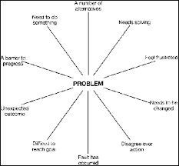

IT is rife with opportunity and challenges. There are plenty of options to learn new and exciting skills, and also to earn high salaries. But new technologies have disrupted the industry, and IT staff and management
1. Workload
Both IT staff and decision-makers are overwhelmed with work demands. It’s sort of a chicken and egg scenario—decision-makers are using increasing workloads as an excuse not to authorize training, and staff are struggling to complete assignments because they lack the proper skills. Either way, time that was previously designated toward skills development is now being used to catch up on an increasing backlog of work.
Better manager oversight and strategy is required to address this issue. Automation may also be a solution as a means to reduce time-consuming tasks that are not high priority.
2. Cybersecurity
The cybersecurity challenge is two-fold:
- Cyberattacks are growing in size and sophistication
- Millions of cybersecurity jobs remain unfilled
Organizations cannot take IT security lightly. An analysis of worldwide identity and access management by the International Data Corporation (IDC) revealed that 55% of consumers would switch platforms or providers due to the threat of a data breach, and 78% would switch if a breach impacted them directly.1 Customers aren’t willing to put their data at risk.
The problem is there aren’t enough IT professionals with cybersecurity expertise. Forty percent of IT decision-makers say they have cybersecurity skills gaps on their teams. It’s also identified as the most challenging hiring area in IT.
There isn’t an immediate solution to this problem, but a long-term fix is to build your cyber workforce from the inside. Invest in cybersecurity training and upskill your current staff. Hiring and outsourcing isn’t always a viable (or cheap) solution. Current IT professionals who know the industry are more apt to transition into successful cybersecurity professionals.

3. Skills gaps
Over 80% of North American IT departments have skills gaps. Globally, IT skills gaps have increased by 155% in three years. They can no longer be ignored, especially as a lack of necessary skills can be credited for increased employee stress, development and deployment delays, and increased operating costs.

The time to act is now—skills gaps will only grow and further debilitate IT departments unless actions are taken. Strategic and continual training is the antidote. That’s the good news. The uphill battle is conveying the value to management and securing budget to ensure employees receive continual training. IT professionals need better support. If organizations do not invest in their employees’ skills now, they will pay for it down the road.
4. Digital transformation
Digital transformation is latest disrupter. It has led to technology no longer providing a sustained competitive advantage. It now plays a supporting role to people with the right skills. Expertise is needed now more than ever to manage and implement all of the new technologies.
But it’s not that simple. As discussed above, IT departments are suffering from gaps in critical skills areas such as cybersecurity, cloud computing and DevOps. Even IT professionals who are offered professional development opportunities are struggling to keep up. The rate of technological change is outpacing training.

IT professionals and departments are falling behind—they are failing to meet business objectives and seize market opportunities. While continual training is part of the equation, prioritizing skill needs is even more of a priority. That’s why we created the Skills Development Index™ to help IT professionals rank their most critical skill needs and determine which type of training to pursue. Informal training has its merits, especially when on-the-fly knowledge must be acquired, but when a high-value project is on the line, more formal learning is the better option.
5. Cloud computing
Cloud is the top investment area worldwide for IT departments. Organizations require an infusion of cloud skills to match their monetary investment in cloud platforms. Much like cybersecurity, cloud professionals are in high demand and short supply. According to IT decision-makers, cloud computing is the second most challenging hiring area in the world.
Despite the worker shortage, organizations are all-in on cloud solutions. In fact, more than 50% of organizations use more than one cloud provider.2 It’s not unique for an organization to require cloud skills in AWS, Microsoft Azure and Google Cloud. And generic cloud computing expertise isn’t enough, especially if you’re an engineer or architect. It’s imperative that cloud professionals have current skill sets and train on the platforms they engage with regularly.
6. Hiring
Talent recruitment and retention is a major challenge for IT leaders—50% are currently struggling in the area. Only seven percent of IT decision-makers say that hiring has been easy.
Managers hoping to hire their way out of a skills gap problem have been dealt a dose of reality, as key positions like cloud computing and cybersecurity are the most difficult to fill.
One potential solution to this quandary is degree deflation, which is a conscientious effort to focus on skills rather than a college degree during the hiring process. A bachelor’s degree is not necessarily an indicator of abilities, especially in tech. Recent training and certifications better illustrate what a professional is capable of right now.
Requiring a four-year degree closes off a potential pipeline to qualified candidates. We suggest removing a degree as a prerequisite and placing a greater emphasis on relevant and actionable skills.
7. Budget
A lack of budget and resources is another major concern for both IT staff and decision-makers. The open-field sections of our IT Skills and Salary Survey are littered with criticisms about budget constraints. IT professionals want to train but their requests aren’t always approved by management.
Budget is often the major roadblock impeding professional development and hiring. IT departments need to ensure they are communicating the right messages to organizational leadership to help them understand the value of ongoing training. Here’s a place to start: revenue growth, low employee turnover and new product development are signs of a skilled workforce.
There are a number of ways to maximize a constrained budget. Prepayments and special offers are options to save on training. Lock in a discounted rate for a full year, or save a certain percentage on individual courses. Also, make sure you are aware of any training credits your company may have. They are typically issued by tech providers as a way to help drive value for a particular investment. Global Knowledge accepts training credits and vouchers as payment for courses. Know your balance and know when they expire.
8. Leadership support in prioritizing new skills development
Some IT decision-makers do not authorize training even when it’s built into their budget—41% had formal training available but decided to forgo it. Nearly 20% of IT professionals say management does not see a tangible benefit from training. That’s a huge disconnect, especially since IT pros have a strong desire to learn and grow their careers. It’s difficult to accomplish that without support from leadership.
Often, IT management, fairly or unfairly, is blamed for poor employee morale and unclear job roles and responsibilities. Communication is one of the biggest gripes—IT professionals believe leadership isn’t always transparent, especially when it comes to decisions about resources and budgets.
9. Analytics and data management
Aside from cybersecurity and cloud computing, this is the biggest skill gap area for IT departments. Organizations are struggling to manage a wealth of new data. By 2025, IDC estimates the world will create and replicate 163 zettabytes (ZB) of data, 10 times the number that was created in 2016.3 New data is constantly accumulating, creating a host of storage and security risks that must be addressed. IT professionals are desperately needed to manage this data growth, but the problem has exacerbated because qualified individuals are difficult to come by.
It’s not enough to accumulate this data. Organizations need analysts and critical thinkers to create a culture of information, enabling data-driven decisions to inform almost all business activities.
10. Automation
Since workload is the biggest challenge for IT professionals, finding ways to automate more mundane and time-consuming tasks such as email sends and social media posting is crucial.
But companies are now looking to automate larger and more business-critical tasks, such as cyberattack response, log monitoring and ERP integration.

Automation’s role in cybersecurity is certainly growing. It’s a tool that should be used to predict cyber threats and implement responses more quickly than can be accomplished manually.
Hackers are using automation to execute their attacks, so it’s time to bring the fight back to them. Automation allows attackers to move quickly, so organizations demand a faster detection and response time.
Automation is also useful in cloud migration. For organizations moving to the cloud, many of the migration tasks, such as manual configuration, can be automated, which reduces migration time from days to minutes.
11. Project management
Companies with certified project managers are more likely to have projects that are completed on time and within budget. It takes experience and strategic thinking to align projects with departmental and organizational goals. A strong project manager keeps projects on track so deadlines are met, resources are available and leadership is in the loop. Without someone to steer the ship, projects lack direction and risk increases. A business that fails to recognize these risks probably doesn’t value project management highly.
Rising skills gaps have made the jobs of project managers even more difficult, as critical expertise is lacking. It’s the project manager’s job to communicate skills needs with management and help guide realistic expectations. IDC believes that by 2020, 90% of all organizations will have adjusted project plans, delayed product/service releases,
12. Career Growth
Share this: Two-thirds of IT professionals who changed employers last year did so in pursuit of better growth and development opportunities. In fact, growth outweighs a higher salary in terms of the top factor for changing employers.
As IT decision-makers struggle to fill open positions, it’s important that they invest in the areas their employees deem valuable. If growth opportunities are not available, IT professionals have proven that they will not sit idly by.

- KT0102 Establishing a probable cause,
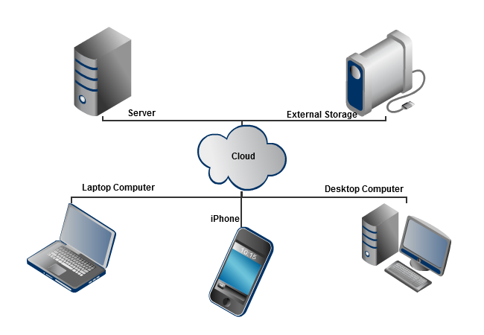

What exactly is Cloud Computing?
Cloud computing is the utilization of virtual servers that information is stored on. This allows for users and companies to save information but not use up space on their personal servers or computers.
The use of cloud computing is appealing to many companies and normal users because it allows them to have more capabilities and efficiency than they actually have equipment for. The use of the cloud and what it can offer can reduce costs for companies because they don’t need to buy new equipment or hire people and train them on how to use this new equipment.
What is the Fourth Amendment?
In essence, the Fourth Amendment prevents illegal searches and seizures of property and related items. This is so that citizens’ homes and related areas are not being randomly searched and have items taken for no reason. Anything that is found by the Police or other investigative forces without the use of a warrant renders the items found useless in court. Anything that is found without a warrant or without probable cause cannot be held against a person.
Does the Fourth Amendment cover Cloud Computing?
It is still unsure about if the Fourth Amendment does actually include data stored in the cloud. The law that would help to clarify this uncertainty would be the Electronic Communications Privacy Act.
- KT0103 Testing to determine the cause,
Testing to determine the cause of a problem is a crucial step for IT professionals when troubleshooting issues in systems or software. By conducting various tests, IT professionals can isolate the root cause of the problem and implement the necessary solutions to resolve it. Common testing methods used by IT professionals include:
Unit Testing: Testing individual components or modules of software to ensure they function correctly.
Integration Testing: Testing the interaction between different components to identify any issues in the integration process.
System Testing: Testing the entire system as a whole to verify that it meets specified requirements.
Regression Testing: Re-testing modified parts of the system to ensure that changes have not adversely affected other functionalities.
Performance Testing: Testing to assess the performance and scalability of the system under various conditions.
Security Testing: Testing to identify vulnerabilities and ensure that the system is secure from potential threats.
By systematically conducting these tests and analysing the results, IT professionals can pinpoint the cause of the problem and take appropriate actions to rectify it effectively.
- KT0104 Establishing a plan to resolve the problem,

How can we solve information technology problems?
- Go Green: Harnessing Technology to Lower Pollution. ...
- Think Smart: The Advent of Next Generation Robotics. ...
- Additive Manufacturing: From Wearables to Printable Organs and SmaA rt Clothes.
- When a Computer Can Learn on the Job.

- KT0105 Implementing your solution,
- Find a technology partner that shares your vision. There are lots of technology companies and lots of technology products. The key to success is finding the one that understands what you’re trying to accomplish. In this case, Masonite and Adecco were trying to reap the benefits of automation while still giving candidates an experience that made them feel special.
- Build processes that accommodate the future. This is an opportunity to streamline solutions. View recruiting as a holistic process not just applicant flow. Corey said it helped her company find a system that performed human capital management software that addressed both reactive hiring (i.e. running ads to fill open requisitions) and proactive hiring (i.e. searching for future talent).
- Incorporate design and branding elements in the solution. Chappelle noted that her hiring managers don’t realize they’re using iCIMS. “Our managers weren’t asking for a third-party technology solution. They wanted a good process. iCIMS gave us the technology and we branded it for our company.”
- Align the user experience to the strategy. Each person that uses technology doesn’t need to see the same things. When the user experience is customized, it changes the focus of the process. Prior to implementation, the focus was on the paper. After implementation, the focus was on the candidate.
- Manage change. Not everyone will adjust to technology at the same pace. Some will long for the “good old days” of paper. Training and patience are essential in adopting a new technology mindset. That’s something to keep in mind when thinking about making upgrades to existing systems. One user group could be totally ready for change while another is still getting the hang of things. Companies can work with their technology partner to introduce features at the right time.
- Don’t forget the reporting. Having a great system is important. But one of the reasons companies automate is to get data and reports. It’s to measure outcomes and share information. We’re talking everything from obligatory government compliance reports to organizational data used to prepare budgets.
- Regularly evaluate the process. Feigenbaum used the term “Frankensystem” to refer those situations where we’ve made a little change here and another change there so, over time, the technology solution is no longer optimized. Building time for evaluation into the regular maintenance will keep the system primed for producing results.

- KT0106 Verifying functionality,
Information Technology Functions
The IT department contributes significantly to an organization’s success that has three broad functions to perform within an organization. They are
- Governance
It alludes to the execution of operational boundaries for working units and people's utilization of IT frameworks, engineering, and organizations.
In layman's terms, they authorize the principles about how you and your group can utilize the organization's innovation and what you can utilize it for.
This is essential for the traditional IT security just as the information affirmation for which the IT office is additionally capable.
- Infrastructure
It refers to all physical components essential for an IT system. It includes hardware, network, and circuitry of equipment according to the needs and size of the organization.
- Functionality
It perhaps is the most important and viable task an IT department performs and this is the reason an IT department is recognized and remembered by others in an organization.
It refers to creating and maintaining operational applications; developing, securing, and storing electronic data that belongs to the organization; and assisting in the use of software and data management to all functional areas of the organization.
- Network Contingencies
A network failure can have significant repercussions- not just within the organization but also on the outside entities that take services of the organization. Moreover,
- It can affect the outside entities in a way that this situation can portray the organization as incapable of serving them and ultimately, they may lose faith in the company.
- So, what the IT department does is it puts a crisis plan in place that can be implemented when the system goes down. The plan may be to switch to an alternative system until the necessary repairs are completed or have a network backup.
- Through the upkeep and arranging of an organizational framework, the IT division must manufacture proficient associations with outside sellers and industry specialists.
- This enables the office representatives to play out their obligations all the more proficiently as well as remain ahead on the most recent innovation that may be fruitful to the organization for which they work.
- Application Development
Regularly, organizations see the principal part of the IT division as making applications that serve its centre business needs. The correct applications allow a business to be imaginative, more gainful, productive, and to push forward of its rivals.
- From multiple points of view, this makes the IT division urgent in driving a business forward.
- The work important to make the applications that can separate a business from the others requires an IT office with developers, researchers, interface designers, database administrators, analysers, and different experts.

- Communication
A great many people know that the IT division is liable for the achievement of PC activities and other data advancements inside a business.
- Notwithstanding, the same number of new types of electronic communication have become staples of the cutting-edge office, IT offices have been taking on a more prominent function in the specialized side of organization correspondence.
- This incorporates highlight point-to-point phone calls, conference calls, and video and web conferences, just as less immediate types of electronic correspondence like organization drives, email frameworks, and secure workers.
- The IT office should completely see how these frameworks function and collaborate with one another, and is answerable for guaranteeing that these frameworks stay operational consistently.

- Company Website
The IT department is responsible, partially if not fully, for creating and maintaining the company’s website. We are saying partially because the content displayed on the website is mostly handled by the Marketing department.
- The IT department typically creates the code and works with other departments to test the functionality. These were some of the functions of the IT department.
- However, It's evident that not all the IT office does is clear - it makes and keeps up numerous frameworks that go concealed or get underestimated by representatives.
- It makes the crisis reaction intend to shield the business from unexpected issues and continually attempts to improve the whole organization's capacity to work proficiently and successfully.

- KT0107 Implementing preventative measures,
What’s required?
The impact of IT must be considered carefully during an evaluation of internal control over financial reporting. There are unique risks to be considered. The controls that mitigate these risks are important because of their pervasive effect on the reliability, integrity and availability of processing and relevant data.
What are IT controls?
IT risks and controls must be evaluated from the top down. There are general controls and there are application controls. General controls typically impact multiple applications in the technology environment and prevent certain events from impacting the integrity of processing or data. Computer operations, physical and logical security, program changes, systems development and business continuity are examples of processes where general IT controls reside. These IT controls are “pervasive” because they can have an impact on the organization’s achievement of financial reporting objectives germane to many of its processes.

Application controls are more specific to individual business processes. These controls include policies and procedures designed and implemented in the business areas by the respective owners of the applications and data. They also include so-called “programmed controls” within the applications that perform specific control-related activities, such as computerized edit checks of input data, numerical sequence checks, validation of key fields, and exception reporting and related follow up on exceptions.

Why are controls over IT important?
IT plays a key role in the financial reporting process. Many economic events are captured in application systems. These transactions are summarized and reported by applications to form the basis for preparing financial statements. For example, the revenue-reporting process in a long-distance telecom company begins with the capture of calls by individuals and businesses. The company bills for these calls based on the data from the telephone-usage system and the contractual terms maintained in the billing system. The individual billings are summarized and the corresponding revenue is recorded in the general ledger. The general ledger for the operating unit is consolidated with the results of other business units by the consolidation system, which then produces the consolidated revenue amounts reported in the financial statements. Thus applications perform many of the routine steps and calculations that are critical to financial reporting. The data in these applications and the calculations they perform must have integrity to ensure fairly presented and reliable financial statements.
Ignoring IT controls is not possible. Almost without exception, every company utilizes IT to record, summarize and report transactions. Unless a company has no computers or its operations are both small and simplistic, IT controls always must be considered when evaluating internal control over financial reporting. Even some manual controls are dependent on technology, e.g., comparing a computer-generated report to something, making sure the general ledger and sub-ledgers agree, using performance metrics to monitor certain activities, etc.

What are examples of key risks in an IT context?
Given IT’s vital role in the financial reporting process, the integrity of the programs (or applications) and data are critical control elements of the internal control environment. Integrity of applications addresses several assertions inherent to processing and reporting, such as effectiveness, efficiency, confidentiality, integrity, availability, compliance and reliability of information. These assertions provide a context for assessing IT risks. For example, the effectiveness assertion provides that information is relevant to the business process and is delivered in a timely, correct, consistent and useful manner. As another example, the confidentiality assertion emphasizes that sensitive information is protected from unauthorized disclosure. These assertions provide a context for assessing IT risks.
IT risks are the events that depict “what can go wrong” to cause failure to meet or achieve the fundamental assertions.

Risks provide a context for evaluating IT and manual controls. For instance, what controls exist to ensure initial data entry is accurate and complete? What controls exist over the technology environment where transactions and other accounting information are stored and maintained? What controls exist to mitigate risks unique to the IT environment? For example, there is a risk that data may be changed through “technical back doors” that exist because of inadequate computer security. The appropriate controls provide assurance that data is changed only in accordance with management’s criteria.

- KT0108 Documenting results
Software documentation is written text or illustration that accompanies computer software or is embedded in the source code. The documentation either explains how the software operates or how to use it, and may mean different things to people in different roles.
Documentation is an important part of software engineering. Types of documentation include:
- Requirements – Statements that identify attributes, capabilities, characteristics, or qualities of a system. This is the foundation for what will be or has been implemented.
- Architecture/Design – Overview of software. Includes relations to an environment and construction principles to be used in design of software components.
- Technical – Documentation of code, algorithms, interfaces, and APIs.
- End user – Manuals for the end-user, system administrators and support staff.
- Marketing – How to market the product and analysis of the market demand.

Internal Assessment Criteria and Weight

- IAC0101 Problem-solving steps and the application thereof are explained.

SECTION 2: KM-06-KT-02 : Operating systems
Learning Outcome
- KT0201 Functions of an operating system: e.g. managing hardware, resources, data, and making user interaction easy through the use of a graphical user interface (GUI)
- KT0202 Big three operating systems: Windows, Linux, and Mac.
- KT0203 Control panel
- KT0204 Remote assistance
- KT0205 OS command prompt
- KT0206 OS migration
- KT0207 OS configurations

- KT0201 Functions of an operating system: e.g. managing hardware, resources, data, and making user interaction easy through the use of a graphical user interface (GUI)
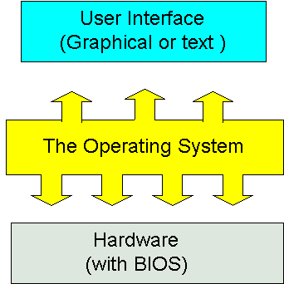

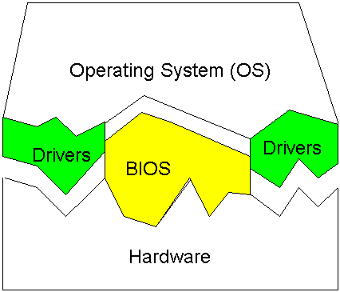

In any computer, the operating system:
- Controls the backing store and peripherals such as scanners and printers.
- Deals with the transfer of programs in and out of memory.
- Organises the use of memory between programs.
- Organises processing time between programs and users.
- Maintains security and access rights of users.
What is managing hardware in operating system?
Drivers teach the operating system to interact with each bit of hardware. Graphics cards, sound cards, networking cards, USB peripherals, and everything else you connect to your computer relies on drivers. The operating system then uses these drivers to ensure correct operation of each device.
What is a Graphical User Interface?
The graphical user interface, developed in the late 1970s by the Xerox Palo Alto research laboratory and deployed commercially in Apple’s Macintosh and Microsoft’s Windows operating systems, was designed as a response to the problem of inefficient usability in early, text-based command-line interfaces for the average user.
Graphical user interfaces would become the standard of user-cantered design in software application programming, providing users the capability to intuitively operate computers and other electronic devices through the direct manipulation of graphical icons such as buttons, scroll bars, windows, tabs, menus, cursors, and the mouse pointing device. Many modern graphical user interfaces feature touchscreen and voice-command interaction capabilities.

How Does a Graphical User Interface Work?
Graphical user interface design principles conform to the model–view–controller software pattern, which separates internal representations of information from the manner in which information is presented to the user, resulting in a platform where users are shown which functions are possible rather than requiring the input of command codes. Users interact with information by manipulating visual widgets, which are designed to respond in accordance with the type of data they hold and support the actions necessary to complete the user’s task.

The appearance, or “skin,” of an operating system or application software may be redesigned at will due to the nature of graphical user interfaces being independent from application functions. Applications typically implement their own unique graphical user interface display elements in addition to graphical user interface elements already present on the existing operating system. A typical graphical user interface also includes standard formats for representing graphics and text, making it possible to share data between applications running under common graphical user interface design software.

Graphical user interface testing refers to the systematic process of generating test cases in order to evaluate the functionality of the system and its design elements. Graphical user interface testing tools, which are either manual or automated and typically implemented by third-party operators, are available under a variety of licenses and are supported by a variety of platforms. Popular examples include: Tricentis Tosca, Squish GUI Tester, Unified Functional Testing (UFT), Maveryx, Appium, and eggPlant Functional.
- KT0202 Big three operating systems: Windows, Linux, and Mac.
Types of operating systems
Operating systems usually come pre-loaded on any computer you buy. Most people use the operating system that comes with their computer, but it's possible to upgrade or even change operating systems. The three most common operating systems for personal computers are Microsoft Windows, macOS, and Linux.
Microsoft Windows
Microsoft created the Windows operating system in the mid-1980s. There have been many different versions of Windows, but the most recent ones are Windows 10 (released in 2015), Windows 8 (2012), Windows 7 (2009), and Windows Vista (2007). Windows comes pre-loaded on most new PCs, which helps to make it the most popular operating system in the world.
macOS
macOS (previously called OS X) is a line of operating systems created by Apple. It comes preloaded on all Macintosh computers, or Macs. Some of the specific versions include Mojave (released in 2018), High Sierra (2017), and Sierra (2016).
Linux
Linux (pronounced LINN-ux) is a family of open-source operating systems, which means they can be modified and distributed by anyone around the world. This is different from proprietary software like Windows, which can only be modified by the company that owns it. The advantages of Linux are that it is free, and there are many different distributions—or versions—you can choose from.
- KT0203 Control panel
The Control Panel is a feature of the Windows operating system that allows the user to modify system settings and controls. It includes several small applications, or control panels, that can be used to view and change hardware or software settings. Some examples of hardware control panels are Display, Keyboard, and Mouse settings. Software control panels include Date and Time, Power Options, Fonts, and Administrative Tools.
Many control panels are included as part of the Windows operating system, but others can be installed by third-party applications or utilities. For example, if you add a new mouse to your computer, it may come with a CD for installing a control panel specific for that mouse. Some graphics cards may also install an additional control panel that gives the user greater control over the computer's visual settings. Regardless of when control panels are installed, they can always be found within the Control Panel folder.
The Windows Control Panel can be accessed by clicking the Start menu and selecting Control Panel. It is also available in the "Other Places" section of the window's sidebar when you open My Computer. In Windows XP and Windows Vista, the Control Panel can be viewed in either Category View or Classic View. Category View arranges the control panels into sections, while Classic View shows them all at once. While the Category View is designed to make locating different settings easier, people familiar with most of the control panels often find the Classic View more efficient.

Control Panels were also used for many years by the Mac OS, through Mac OS 9. However, with the introduction of Mac OS X, control panels were consolidated into a single interface called System Preferences. The control panels themselves are now called "Preference Panes" in Mac OS X. They can be accessed by selecting "System Preferences" from the Apple menu or by clicking the System Preferences icon in the Dock.

- KT0204 Remote assistance
Use Windows Remote Assistance
All current versions of Windows include a utility that can be used to request assistance from another Windows user over the Internet. While the particular steps and screens are a bit different in each version of Windows, the procedure is basically the same. Essentially, the person wanting assistance runs "Windows Remote Assistance" to create an encrypted invitation file and a secure password. The requester then emails this invitation to someone they trust (such as CTI technicians) to connect to and temporarily control their computer. The person requesting help must have Remote Assistance and Remote Desktop Connections enabled in their Windows

- KT0205 OS command prompt
What is the Command Prompt?
In Windows operating systems, the Command Prompt is a program that emulates the input field in a text-based user interface screen with the Windows Graphical User Interface (GUI).
It can be used to execute entered commands and perform advanced administrative functions. It can also be used to troubleshoot and solve certain kinds of Windows issues.

- KT0206 OS migration
Challenges in operating system migrations
Once an organization makes the decision to upgrade their workstations to a new operating system, IT service providers are faced with extensive pre-deployment auditing and planning in order to implement a successful rollout with minimal disruption to the organization’s day-to-day operations. In addition, the IT service provider’s goal is to limit the number of helpdesk calls due to missing drivers, user data, applications, or configuration settings.
1. Hardware compliance audit
IT service providers typically start the project by auditing the organization’s existing environment to determine what type of hardware is used by their customer base. This allows IT service providers to determine how many different hardware models are supported and whether they meet the requirements of the new operating system. In some cases, the existing hardware is insufficient and will need to be replaced outright. In other cases, the existing hardware only requires minor upgrades to system memory or disk space. In cases where the current hardware models are supported by the new operating system, IT service providers will need to verify that the new hardware drivers for each model are supported.

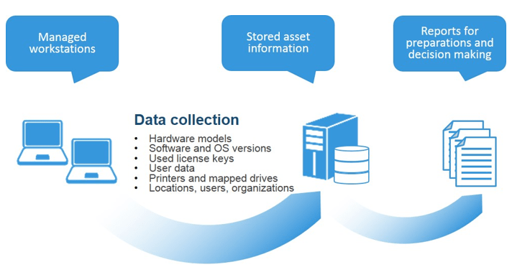

2. Software compliance audit
A review of the corporate software standard is performed to determine the state of the existing standard and determine if any software can be added or removed. In addition, IT service providers use the software audit to ensure all software is still supported by the new operating system; if software is not supported, new versions or replacements for the software need to be identified.
In addition to corporate standards, each business unit and location within the organization has individual standards based on their business function. For example, all the employees within the sales organization might require CRM software, but the engineering department requires CAD software. In addition to business unit requirements, each location and country can have specific software that must be identified and supported including operating system settings like time zones, language preferences, keyboard settings, etc. for each country.
Once the organization, business unit, and location specific software standards have been identified, the IT service providers need to perform an audit on the individual user’s software requirements to identify and ensure individual software requirements are not missed during the re-installation of the workstation. Special attention needs to be paid in order to ensure that users’ software licenses are recorded and copied when re-installing individual software.

This single requirement can be one of the biggest challenges for an operating system refresh project and typically results in the majority of post replacement tickets and user complaints.
Upon completion of the software audit, IT service providers must test and certify all existing software products in order to verify that they are supported by the new operating system. This process will produce a list of all supported and unsupported software and identify any risks to the project. In addition, it provides the IT service providers with a list of software that is supported by the new operating system.

3. Software license compliance audit
Upon completion of the corporate standard and user specific software audits, a software license compliance audit is performed in order to determine if the organization is compliant with the actual licenses purchased by the organization. If the audit determines that additional software is installed within the organization, then the organization can decide whether new licenses should be purchased or existing software removed. When software is removed from existing users during the migration process, the end users typically experience frustration and lost time while they submit new requests to get the software approved and installed.
In many cases during the audit process, questions are raised to determine if the software is actually being used or even required by a user. When and why was the software installed? Was the installation approved by someone and does the user or organization have a license key for the software?
4. User data and configurations audit
Care needs to be taken in determining where users are storing their personal data on the device and steps taken to ensure this data is backed up and restored back to the device when the operating system has been upgraded.

- KT0207 OS configurations
Operating system configurations
Each device can be defined to one or more operating systems. The hardware configuration contains this definition information, known as the operating system (OS) configuration. Note that you may define devices and their associated parameters to an OS configuration, even if they are not explicitly connected.
- Typically, the OS configuration is associated with a processor or partition. Each processor can run different OS configurations at different times. There are two types of OS configuration: MVS and VM.
- An MVS OS configuration can contain one or more EDTs. An Eligible Device Table or EDT is a list of esoteric device groups, plus the names of the generic device types which determine how devices are used (order of preference) within each esoteric. The EDT is identified by a two-digit ID; you must define at least one EDT for each MVS OS configuration.

- An esoteric device group or esoteric is an installation-defined and named grouping of I/O devices under an EDT. An esoteric act as a single “virtual device” which can be allocated without using a specific device number. Devices within an esoteric are usually from the same device group, but can be of different device types.
Every device type is associated with a generic device group or generic. A generic is an MVS-defined grouping of devices with similar characteristics, which determines how devices are used in an esoteric device group. Each generic has a preference number which governs the order of allocation of devices to jobs within an esoteric. For example, if the esoteric contains the device types 3390, 3380 and 3350, and the generics associated with the device types have preference numbers 280, 290 and 300, respectively, then the preference numbers are used by the MVS allocation component to assign the devices in that order of preference.
Faster devices have lower preference numbers. You can change the preference number of a generic under an EDT (user-defined generic), but not under an OS configuration (system-defined generic).

Internal Assessment Criteria and Weight

- IAC0201 An understanding of operating systems is demonstrated.

SECTION 3: KM-06-KT-03 : Managing files
Learning Outcome
- KT0301 Files and directories, naming conventions, and the File Allocation Table (FAT)
- KT0302 Common executable file extensions, such as batch files, command files, and power shell scripts and purpose

- KT0301 Files and directories, naming conventions, and the File Allocation Table (FAT)
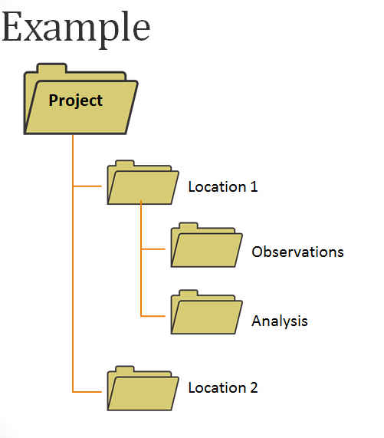

File naming
Descriptive file names are an important part of organizing, sharing, and keeping track of data files. Develop a naming convention based on elements that are important to the project.
File naming best practices:
- Files should be named consistently
- File names should be short but descriptive (<25 characters) (Briney, 2015)
- Avoid special characters or spaces in a file name
- Use capitals and underscores instead of periods or spaces or slashes
- Use date format ISO 8601: YYYYMMDD
- Include a version number (Creamer et al. 2014)
- Write down naming convention in data management plan
Elements to consider using in a naming convention are:
- Date of creation (putting the date in the front will facilitate computer aided date sorting)
- Short Description
- Work
- Location
- Project name or number
- Sample
- Analysis
- Version number
Example
- YYYY MM DD_Image_Modification
- 20130420_tina_original.tiff
- 20130420_tina_cropped.jpeg
- 20130420_tina_mustache.jpeg

Location Analysis Version
- CarnegieLakeWordCloudV1
- CarnegieLakeMapV1
- CarnegieLakeMapV2
- Research Data Mantra
For more on file naming, including batch renaming tools, visit the Research Data Management Training module on organizing data from the University of Edinburgh.
File structure
Hierarchical file structures can add additional organization to your files. As with file naming use whatever makes most sense for your data. Some possibilities include:
- Project
- Date
- Analysis
- Location

File allocation table (FAT)
A file allocation table (FAT) is a table that an operating system maintains on a hard disk that provides a map of the clusters (the basic units of logical storage on a hard disk) that a file has been stored in. When you write a new file to a hard disk, the file is stored in one or more clusters that are not necessarily next to each other; they may be rather widely scattered over the disk. A typical cluster size is 2,048 bytes, 4,096 bytes, or 8,192 bytes. The operating system creates a FAT entry for the new file that records where each cluster is located and their sequential order. When you read a file, the operating system reassembles the file from clusters and places it as an entire file where you want to read it. For example, if this is a long Web page, it may very well be stored on more than one cluster on your hard disk.
Until Windows 95 OSR2 (OEM Release 2), DOS and Windows file allocation table entries were 16 bits in length, limiting hard disk size to 128 megabytes, assuming a 2,048 size cluster. Up to 512-megabyte support is possible assuming a cluster size of 8,192 but at the cost of using clusters inefficiently. DOS 5.0 and later versions provide for support of hard disks up to two gigabytes with the 16-bit FAT entry limit by supporting separate FATs for up to four partitions.
With 32-bit FAT entry (FAT32) support in Windows 95 OSR2, the largest size hard disk that can be supported is two terabytes! However, personal computer users are more likely to take advantage of FAT32 with 5 or 10 gigabyte drives.

- KT0302 Common executable file extensions, such as batch files, command files, and power shell scripts and purpose
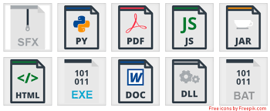

The most common document file extensions are:
- DOC and DOCX.
- HTML and . HTM.
- ODT.
- PDF.
- XLS and XLSX.
- ODS.
- PPT and . PPTX.
- TXT.

Windows PowerShell is a command-line shell and scripting language designed especially for system administration. Its analogue in Linux is called as Bash Scripting. Built on the .NET Framework, Windows PowerShell helps IT professionals to control and automate the administration of the Windows operating system and applications that run on Windows Server environment.
Windows PowerShell commands, called cmdlets, let you manage the computers from the command line. Windows PowerShell providers let you access data stores, such as the Registry and Certificate Store, as easily as you access the file system.
In addition, Windows PowerShell has a rich expression parser and a fully developed scripting language. So in simple words you can complete all the tasks that you do with GUI and much more. Windows PowerShell Scripting is a fully developed scripting language and has a rich expression parser/
Features
- Cmdlets − Cmdlets perform common system administration tasks, for example managing the registry, services, processes, event logs, and using Windows Management Instrumentation (WMI).
- Task oriented − PowerShell scripting language is task based and provide supports for existing scripts and command-line tools.
- Consistent design − As cmdlets and system data stores use common syntax and have common naming conventions, data sharing is easy. The output from one cmdlet can be pipelined to another cmdlet without any manipulation.
- Simple to Use − Simplified, command-based navigation lets users navigate the registry and other data stores similar to the file system navigation.
- Object based − PowerShell possesses powerful object manipulation capabilities. Objects can be sent to other tools or databases directly.
- Extensible interface. − PowerShell is customizable as independent software vendors and enterprise developers can build custom tools and utilities using PowerShell to administer their software.

PowerShell in action
Take a look at how PowerShell is being used in different scenarios and on different platforms.
- PowerShell remoting over SSH
- Getting started with Azure PowerShell
- Building a CI/CD pipeline with DSC
- Managing Microsoft Exchange

Internal Assessment Criteria and Weight

- IAC0301 Types of files and the respective purposes are identified.

SECTION 4: KM-06-KT-04 : Applications utility, troubleshooting, and optimization
Learning Outcome
- KT0401 Upgrade and remove applications from computers.
- KT0402 New installs through disc or internet download.
- KT0403 Common processes for downloading and removing software.
- KT0404 Troubleshooting
- KT0405 Optimisation

- KT0401 Upgrade and remove applications from computers.
How do I upgrade my apps?
- Open the Google Play Store app .
- At the top right, tap the profile icon.
- Tap Manage apps & device. Apps with an update available are labeled "Update available."
- Tap Update
There are different ways to remove apps and programs, so if you can't find the one you're looking for, you can try another location. Note that some apps and programs are built into Windows and can't be uninstalled. You can try to repair a program first, if it's just not running correctly.

Uninstall from the Control Panel (for programs)
1.In the search box on the taskbar, type Control Panel and select it from the results.
2.Select Programs > Programs and Features.
3.Press and hold (or right-click) on the program you want to remove and select Uninstall or Uninstall/Change. Then follow the directions on the screen.

- KT0402 New installs through disc or internet download.
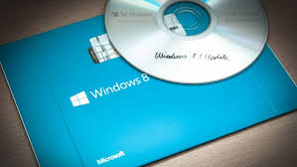

- Installing from a CD-ROM
From the mid-1990s through the late 2000s, the most common way to get new software was to purchase a CD-ROM. You could then insert the disc, and the computer would walk you through the installation.
Now, almost all software has moved away from this model. Many new computers no longer include a CD-ROM for this reason. However, if you do need to install software from a CD-ROM, simply insert the disc into your computer, then follow the instructions.
- Installing software from the Web
Today, the most common way to get new software is to download it from the Internet. Applications like Microsoft Office and Adobe Photoshop can now be purchased and downloaded right to your computer. You can also install free software this way. For example, if you wanted to install the Google Chrome web browser, you can visit this page and click the Download button.
The installation file will be saved to your computer in .exe format. Pronounced dot e-x-e, this is the standard extension for installation files on Windows computers. You can follow the steps below to install an application from an .exe file.

- KT0403 Common processes for downloading and removing software.


What is the download process?
Downloading is the transmission of a file or data from one computer to another over a network, usually from a larger server to a user device. Download can refer to the general transfer of data or to transferring a specific file. It can also be called to download, DL or D/L.

Uninstalling software from your Windows PC
If you find that you no longer use an application, you can uninstall the software to remove it from your computer. This is a good way to clear up space on your hard drive and keep your computer free of clutter.
1.Open the Control Panel.
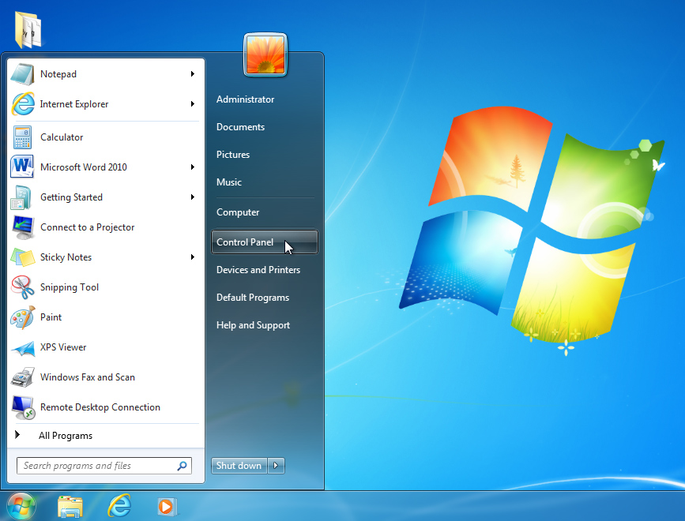

2.Select Uninstall a program (in the Programs category).
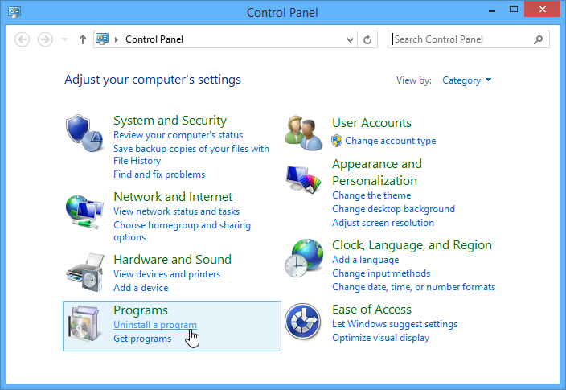

3.Select the desired application, then click Uninstall.
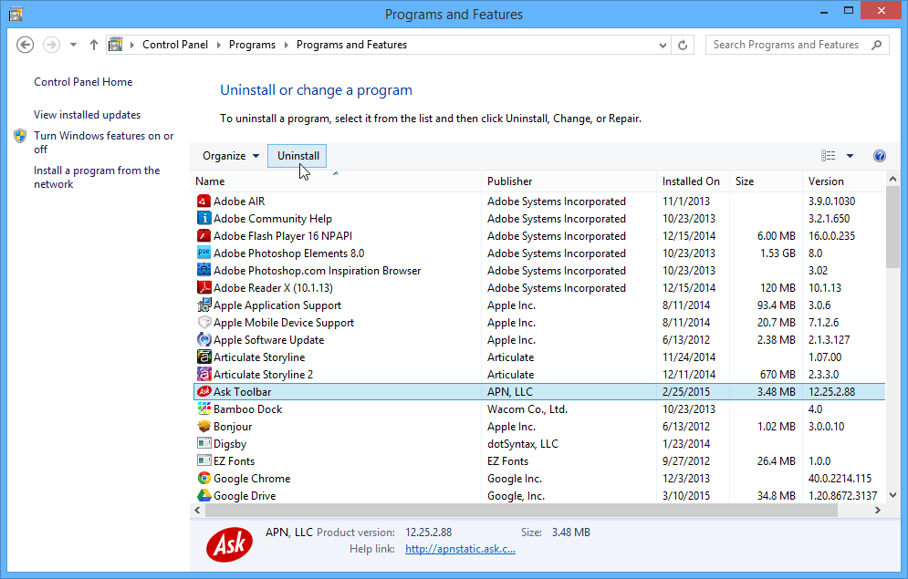

4.Confirm the uninstallation.
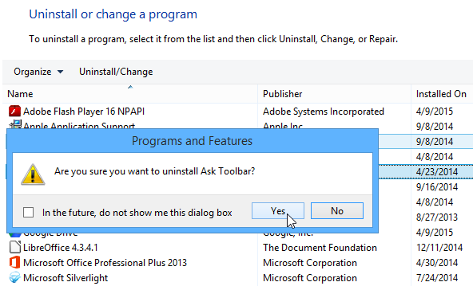

- KT0404 Troubleshooting
Troubleshooting Software
- Free up RAM by closing other open programs. ...
- Restart the software. ...
- Shut down and restart your computer. ...
- Use the Internet to find help. ...
- Undo any recent hardware or software changes. ...
- Uninstall the software, then reinstall it. ...
- Look for software patches. ...
- Scan for viruses and malware.

- KT0405 Optimisation
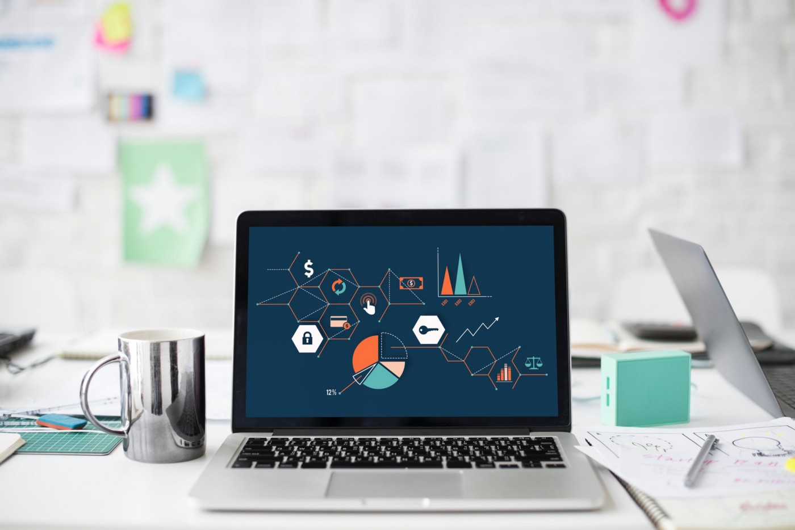

Performance Optimization of a programs and software is the process modifying a software system to make it work more efficiently and execute more rapidly.
Performance optimization is key in having an efficiently functional application and is done by monitoring and analysing the performance of an application and identifying ways to improve it.
Performance optimization generally focuses on improving just one or two aspect of the system’s performance, e.g. execution time, memory usage, disk space, bandwidth etc. This will usually require a trade-off where one aspect is implemented at the expense of others. For example, increasing the size of cache improves run-time performance, but also increases the memory consumption.
Levels of Optimization
Design Level
- The design of the system may be optimized to make best use of the available resources, given goals, and expected load.
- The architectural design of a system plays a major role and overwhelmingly affects the system’s performance.
- For example, a system that is network latency can be optimized to minimize network requests, ideally making a single request rather than multiple requests.
Algorithms and Data Structures
- The algorithm and data structures play a very key role and is crucial to the system’s performance.
- To ensure a system is optimized, we should make sure the algorithms are constant O(1), logarithmic O(log n), linear O(n), or log-linear O(n log n).
- Quadratic complexity algorithms O(n2) fail to scale
- Abstract data types are more efficient for system optimizations
Source code level
- On implementation of algorithms, the source code choices are also quite crucial on system optimization.
Build level
- Disabling un-required software features during the build process can effective in optimizing for specific processor models
Internal Assessment Criteria and Weight

- IAC0401 Procedures for installing and removing utilities are described.

SECTION 5: KM-06-KT-05 : Configuring device drivers
Learning Outcome
- KT0501 Configuring device drivers
- KT0502 Changing device settings
- KT0503 Updating drivers
- KT0504 Removing device drivers
- KT0505 Plug-and-play devices
- KT0506 Device failure
- KT0507 System restore points

- KT0501 Configuring device drivers
What is device driver driver configuration?
In computing, a device driver is a computer program that operates or controls a particular type of device that is attached to a computer or automaton.
In computing, a device driver is a computer program that operates or controls a particular type of device that is attached to a computer or automaton. A driver provides a software interface to hardware devices, enabling operating systems and other computer programs to access hardware functions without needing to know precise details about the hardware being used.
A driver communicates with the device through the computer bus or communications subsystem to which the hardware connects. When a calling program invokes a routine in the driver, the driver issues commands to the device (drives it). Once the device sends data back to the driver, the driver may invoke routines in the original calling program.
Drivers are hardware dependent and operating-system-specific. They usually provide the interrupt handling required for any necessary asynchronous time-dependent hardware interface.
Methods of installing device drivers

Admins can install device drivers on a server in four ways.
Running the Setup. Device drivers are automatically installed for all detected devices during installation of Windows 2000 system on the server computer
Starting the computer. Whenever the server is started, new devices are detected and their device drivers are automatically installed
Scanning for new hardware. Add/Remove Hardware Wizard can be used to perform the hardware-detection process and desired device driver installation
Manual installation. You can use the Add/Remove Hardware Wizard to specify the device you want to install, or you can right-click the .INF file that comes with the driver and choose Install.
Note: You must have administrative privileges on the server to install device drivers

Configuring devices using Device Manager
Device Manager displays information about all devices installed on your server. It displays a list of devices that were either detected or for which drivers are installed. The icon for the device indicates whether the device is in proper working condition.
Normal icon indicates that the device driver has initialized successfully while an Exclamation point on icon would mean that device is incorrectly configured and a Stop sign on icon means that device could not be initialized due to hardware conflicts.
To resolve hardware conflicts and to override the resources or the device driver that were assigned to a device, follow these steps:
Start Device manager by typing 'Devmgmt.msc' in the Run dialog box.
Right-click the desired device and select Properties.
Click the Resources tab on the Properties dialog box.
Click the resource to be changed and then clear the "Use automatic settings" checkbox.
Click Change Setting and then change the value of the setting to the desired value.
However best thing to do is to let Plug and Play resolve conflicts whenever possible.

Updating and removing device drivers
Administrators often have to update the existing device drivers or remove them. To update a device driver:
Start Device Manager by typing 'Devmgmt.msc' in the Run dialog box.
Right-click the desired device and select Properties.
Click the 'Driver' tab and then click the Update Driver button.
To remove a device:
- Start Device Manager by typing 'Devmgmt.msc' in the Run dialog box.
- Right-click the desired device and select Properties.
- Click the 'Driver' tab and then click Uninstall button
- KT0502 Changing device settings
Step 1: Press Windows+Pause Break to open System in Control Panel, and click Advanced system settings.
Step 2: Select Hardware and tap Device Installation Settings to move on.
Step 3: Choose No, let me choose what to do, deselect or select Always install the best driver software from Windows Update, Never install driver software from Windows Update and Automatically get the device app and info provided by your device manufacturer, and then hit Save Changes.
- KT0503 Updating drivers
Update drivers in Windows
- In the search box on the taskbar, enter device manager, then select Device Manager.
- Select a category to see names of devices, then right-click (or press and hold) the one you'd like to update.
- Select Search automatically for updated driver software.
- Select Update Driver.

- KT0504 Removing device drivers
Uninstall a Driver
When you need to uninstall a driver completely, the best and safest method is to use the device’s uninstaller program (if it has one). If you added the device to your system through an installer (as is the case with most graphics card and sound card drivers, for instance), you can uninstall it just as you would any other program.
- Click Start, type Uninstall Program, and press Enter.
- In the Uninstall window that appears, go through the list and find your device or drivers. Double-click the entry to begin the uninstallation process.
Sometimes devices won’t have an uninstaller, or the uninstaller will not appear in the list. In those instances, you can use the Device Manager to remove the driver completely.
- Click Start, type Device Manager, and press Enter.
- Find and double-click the category of device whose driver you wish to uninstall (for example, the graphics card would be listed under Display Adapters).
- Right-click the device, and click Uninstall.
- Windows will prompt you to confirm the device’s removal. Click OK to remove the driver.
- After the uninstallation is complete, reboot your computer as soon as possible.

- KT0505 Plug-and-play devices
Plug and Play (PnP) is the part of Windows that enables a computer system to adapt to hardware changes with minimal intervention by the user. A user can add and remove devices without having to do manual configuration, and without knowledge of computer hardware. For example, a user can dock a portable computer and use the docking station keyboard, mouse, and monitor without making manual configuration changes.

PnP requires support from device hardware, system software, and drivers. Initiatives in the hardware industry define standards for easy identification of add-in boards and system components. This Windows Driver Kit (WDK) documentation focuses on the system software support for PnP and how drivers use that support to implement PnP.
The system software support for PnP, together with PnP drivers provides the following:
- Automatic and dynamic recognition of installed hardware
- Hardware resource allocation (and reallocation)
The PnP manager determines the hardware resources requested by each device (for example, input/output ports, interrupt requests, direct memory access channels, and memory locations) and assigns hardware resources appropriately. The PnP manager reconfigures resource assignments when necessary, such as when a new device is added to the system that requires resources already in use.
Drivers for PnP devices do not assign resources; instead, the requested resources for a device are identified when the device is enumerated. The PnP manager retrieves the requirements for each device during resource allocation. Resources are not dynamically configurable for legacy devices, so the PnP manager assigns resources to legacy devices first.
- Loading of appropriate drivers
- A programming interface for drivers to interact with the PnP system
- The interface includes I/O manager routines, Plug and Play minor IRPs, required standard driver routines, and information in the registry.
- Mechanisms for drivers and applications to learn of changes in the hardware environment and take appropriate actions
PnP enables drivers and user-mode code to register for, and be notified of, certain hardware events.

- KT0506 Device failure


Device failure
An engineering definition for device failure is “the nonperformance or inability of a component or system to perform its intended function for a specified time under specified environmental conditions.”78 For MCS devices, failures include hardware and software failures.

- KT0507 System restore points
A system restore point is an image of the system configuration and settings in the Windows Registry that helps in restoring the system to an earlier date when the system was running perfectly. You can create a system restore point manually from the System Protection tab of the System Properties window.
Where can I find System Restore Points?
Press Windows key + R to invoke the Run dialog. In the Run dialog box, type rstrui and hit Enter to open System Restore. On the System Restore window that opens, click/tap on Next. All current restore points will now be listed with a Date and Time created, Description, and Type of restore point for each.

Internal Assessment Criteria and Weight

- IAC0501 Considerations for configuring device drivers are reasoned.

SECTION 6: KM-06-KT-06 : Networking and wireless connections
Learning Outcome
- KT0601 Peer-to-peer networks and server networks,
- KT0602 Common functionality of server networks,
- KT0603 Three types of network topology: Bus, Star, and Ring networks
- KT0604 Networking devices including network interface cards, repeaters, bridges, routers,
gateways, hubs, and switches

- KT0601 Peer-to-peer networks and server networks,

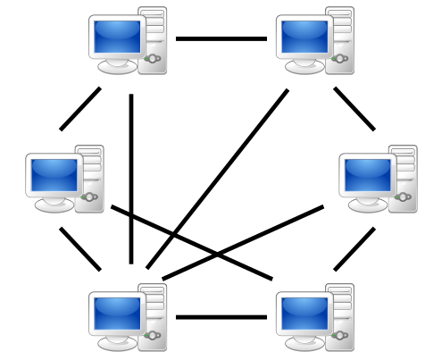

What is Peer to Peer Network
In a peer-to-peer network, there is no specific client or a server. A device can send and receive data directly with each other. Each node can either be a client or a server. It can request or provide services accordingly. A node is also called a peer.
In peer-to-peer network, a node joins the network and start providing services and request for services from other nodes. There are two methods to identify which node provides which service. A node registers the service it provides into a centralized lookup service. When any node requires obtaining a service, it checks the centralized lookup to find which node provides which facilities. Then, the service providing node and service requesting node communicate with each other. In the other method, a node that requires specific services can send a broadcast message to all other nodes requesting a service. Then, the node that has the required service responds to the requested node by providing the service.
There are multiple advantages in peer-to-peer network. It is easier to maintain. It is not necessary to have a specialized expert to maintain the network. The entire network does not depend on a single machine. Moreover, it does not require extensive hardware to set up the network. On the other hand, a peer-to-peer network is not very secure. It can also be difficult to maintain an organized file structure. Furthermore, the users need to manage their own backups.
What is a Client Server Network?
In a client server network, there are clients and servers. A client can be a device or a program. It helps the end users to access the web. Some examples of clients are desktop, laptops, smartphones, web browsers, etc. A server is a device or a program that responds to the clients with the services. It provides files, databases, web pages, shared resources according to its type.
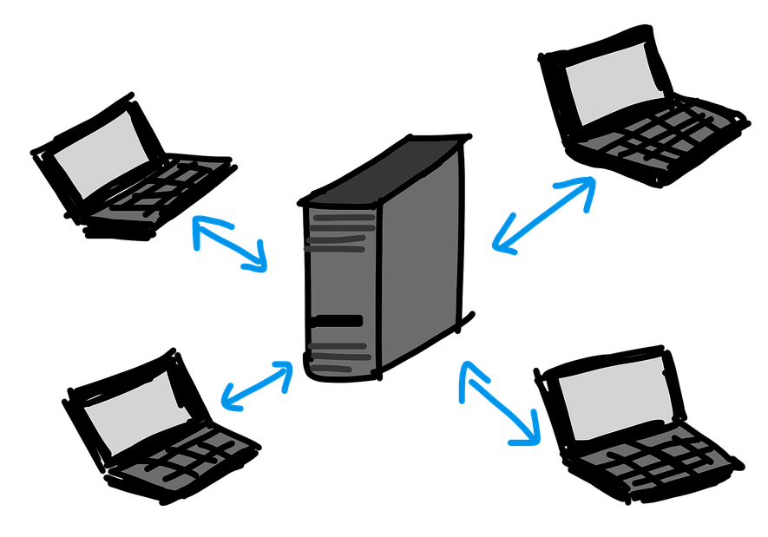

In this network, a client requests services from the server. The server listens to the client requests and responds to them by providing the required service. The main advantage of a client server network is that it more secure as the server always manages the access and security. It is also easier to take backups. On the other hand, it is not very reliable as a failure in the server will affect the functioning of the clients. Furthermore, it is expensive to set up and maintain.

- KT0602 Common functionality of server networks,
A network server can have many roles
- store and share your files;
- share a single internet connection between all your devices;
- manage incoming and outgoing email;
- allow staff to access files when out and about through a virtual private network (VPN);

- KT0603 Three types of network topology: Bus, Star, and Ring networks
Topologies
There are different ways of setting up a LAN, each with different benefits in terms of network speed and cost. Three of the main topologies include bus, star and ring.

Bus network
In a bus network all the workstations, servers and printers are joined to one cable - 'the bus'. At each end of the cable a terminator is fitted to stop signals reflecting back down the bus.

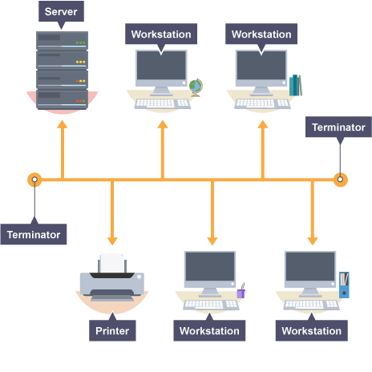

Advantages
- easy to install
- cheap to install - it does not require much cabling
Disadvantages
- if the main cable fails or gets damaged, the whole network will fail
- as more workstations are connected, the performance of the network will become slower because of data collisions
- every workstation on the network 'sees' all of the data on the network, which can be a security risk
Ring network
In a ring network, each device (eg workstation, server, printer) is connected in a ring so each one is connected to two other devices. Each data packet on the network travels in one direction. Each device receives each packet in turn until the destination device receives it.
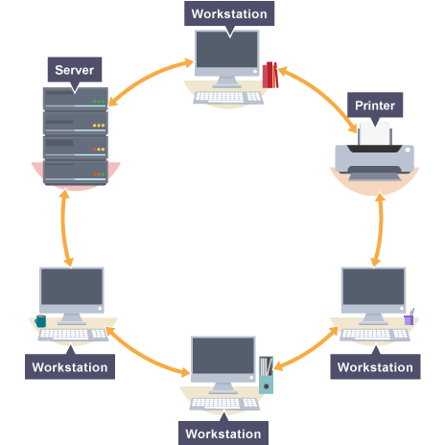

Advantages
- this type of network can transfer data quickly (even if there are a large number of devices connected) as data only flows in one direction so there won't be any data collisions
Disadvantages
- if the main cable fails or any device is faulty, then the whole network will fail - a serious problem in a company where communication is vital
Star network
In a star network, each device on the network has its own cable that connects to a switch or hub. This is the most popular way of setting up a LAN. You may find a star network in a small network of five or six computers where speed is a priority.
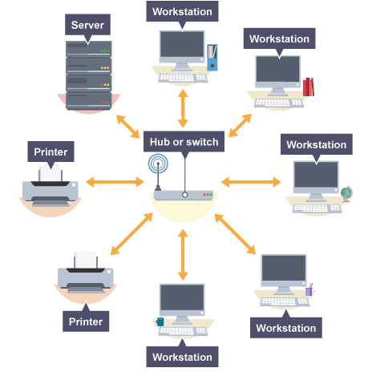

Advantages
- very reliable – if one cable or device fails, then all the others will continue to work
- high performing as no data collisions can occur
Disadvantages
- expensive to install as this type of network uses the most cable, and network cable is expensive
- extra hardware is required - hubs or switches - which add to the cost
- if a hub or switch fails, all the devices connected to it will have no network connection

- KT0604 Networking devices including network interface cards, repeaters, bridges, routers, gateways, hubs and switches
What is a Network Interface Card?
Definition: Network interface card NIC is a hardware component, where network controllers are integrated on to a circuit board that uses standard OSI model of 7 layers to communicate and it acts like a trans-receiver, where it can transmit and receives at the same time while communicating with other devices. Suppose if we want to communicate with another device, let us assume the case of client and server, where the communication between them takes place by firstly sending signals to the physical layer, and then transmitting data packets to the network layer which is an interface at TCP/IP. Connection to the motherboard is made using any one of the following via
- PCI connector
- ISA connector
- ISA connector
- PCI-E
- FireWire
- USB
- Thunderbolt.
Types of Network Interface Cards
There are two types NIC they are,
- Ethernet NIC
- Wireless Network NIC
Internal Assessment Criteria and Weight

- IAC0601 Networking and wireless connections are discussed with reference to types and functionality.

SECTION 7: KM-06-KT-07 : Recovery
Learning Outcome
- KT0701 Recovering systems and disaster recovery
- KT0702 Process for disaster recovery
- KT0703 Expecting things to go wrong
- KT0704 Using boot logs to troubleshoot problems
- KT0705 Process for booting a system into safe mode
- KT0706 Emergency repair
- KT0707 Factory repair partitions
- KT0708 Startup repair
- KT0709 System image recovery

- KT0701 Recovering systems and disaster recovery
What is disaster recovery?
Disaster recovery (DR) is an organization's ability to respond to and recover from an event that negatively affects business operations. The goal of DR methods is to enable the organization to regain use of critical systems and IT infrastructure as soon as possible after a disaster occurs. To prepare for this, organizations often perform an in-depth analysis of their systems and create a formal document to follow in times of crisis. This document is known as a disaster recovery plan.
Read on to learn more about why DR is important, how it works, and the difference between disaster recovery and business continuity. You'll also discover what to include in a disaster recovery plan and the major types of DR, as well as major DR services and vendors.

What is a disaster?
The practice of DR revolves around events that are serious in nature. These events are often thought of in terms of natural disasters, but they can also be caused by systems or technical failure or by humans carrying out an intentional attack. They are significant enough to disrupt or completely stop critical business operations for a period of time. Types of disaster include:
- Cyber attacks such as malware, DDoS and ransomware attacks
- Sabotage
- Power outages
- Equipment failure
- Epidemics or pandemics, such as COVID-19
- Terrorist attacks or threats
- Industrial accidents
- Hurricanes
- Tornadoes
- Earthquakes
- Floods
- Fires
Why is disaster recovery important?
Disasters can inflict many types of damage with varying levels of severity, depending on the scenario. A brief network outage could result in frustrated customers and some loss of business to an e-commerce system. A hurricane or tornado could destroy an entire manufacturing facility, data center or office.

- KT0702 Process for disaster recovery
What's in a disaster recovery plan?
Once an organization has thoroughly reviewed its risk factors, recovery goals and technology environment, it can write a DR plan. The DR plan is the formal document that specifies these elements and outlines how the organization will respond when disruption or disaster occurs. The plan details recovery goals including RTO and RPO as well as the steps the organization will take to minimize the effects of the disaster.
The components of a DR plan should include:
- A DR policy statement, plan overview and main goals of the plan.
- Key personnel and DR team contact information.
- A step-by-step description of disaster response actions immediately following an incident.
- A diagram of the entire network and recovery site.
- Directions for how to reach the recovery site.
- A list of software and systems that staff will use in the recovery.
- Sample templates for a variety of technology recoveries, including technical documentation from vendors.
- A communication that includes internal and external contacts, as well as boilerplate for dealing with the media.
- Summary of insurance coverage.
- Proposed actions for dealing with financial and legal issues.
An organization should consider its DR plan a living document. Regular disaster recovery testing should be scheduled to ensure the plan is accurate and will work when a recovery is required. The plan should also be evaluated against consistent criteria whenever there are changes in the business or IT systems that could affect DR.

- KT0703 Expecting things to go wrong
What are some of the issues associated with disaster recovery?
- There is no plan.
- The plan is wrong or inadequate.
- The plan relies on the wrong technology.
- The plan is not properly tested.
- The plan has insufficient information management.

- KT0704 Using boot logs to troubleshoot problems
How do I troubleshoot system booting issues?
- Try Windows Safe Mode. ...
- Check Your Battery. ...
- Unplug All Your USB Devices. ...
- Turn Off Fast Boot. ...
- Check Your Other BIOS/UEFI Settings. ...
- Try a Malware Scan. ...
- Boot to Command Prompt Interface. ...
- Use System Restore or Startup Repair.

- KT0705 Process for booting a system into safe mode
Boot Windows 10 in Safe Mode
- Click on Power button. You can do this on the loginscreen as well as in Windows.
- Hold Shift and click Restart.
- Click on Troubleshoot.
- Select Advanced Options.
- Select Startup Settings and click Restart. ...
- Choose 5 – Boot into safe mode with Networking. ...
- Windows 10 is now booted in Safe mode.

- KT0706 Emergency repair
Emergency, as name suggests, means stressful events that can cause greater damages. Any type of emergency requires immediate action to be performed. Emergency Maintenance (EM) is a type of maintenance action that is required to perform immediately whenever any emergency i.e. equipment or asset failures occurs unexpectedly. EM is performed to restore asset back to its normal working condition.

Emergency maintenance generally aims at preventing lives of employees, technicians, production, product quality, reliability, profitability, and viability of an organization.

Steps to Perform EM Effectively:
Performing EM is important and is not an easy task. To get most output from EM, one needs to perform EM effectively step by step. One should always follow some rules and procedures as well as protocols also to minimize chances of mistakes, risk of safety, and increasing speed of working. To perform EM effectively, there are four major steps that one should follow. These steps are given below:

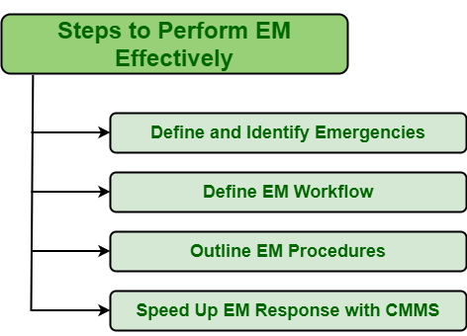

Define and Identify Emergencies:
One needs to understand what actually emergency means before proceeding towards any measures. Emergency is something that causes greater threat to life’s, system, production, etc. and therefore requires immediate action to be taken to minimize its impact. Not every failure or issue that occurs considered emergencies. One needs to able to differentiate between failures or breakdowns that are true emergencies and failures that are not emergencies. There can be two types of situations of failures as given below:
- True emergencies –
These are failures that are very critical and cause greater damage to system. These failures are required to addressed immediately after failure occurs so that its negative impact can be minimized. These failures are considered true emergencies.
- Non-emergencies –
These are failures that are not critical and causes do not cause greater damage to system. These failures do not require to be addressed immediately after failure occurs and can be addressed later whenever possible. These failures are considered non-emergencies.
Therefore, it’s very essential for one to understand, identify, and define failure that is true emergencies so that immediate action can be taken. It simply helps organizations to deal with situations more effectively and manage their resources that are important to resolve such situations.

Define Emergency Maintenance Workflow:
After deciding failures that are considered emergency, second step is to define how emergency action will be implemented, about its details, how it’s going to end. These all are important points and should be recorded. These record or workflow can be done either in two ways:
- Manual Response –
In this response, record is usually created by employees without any involvement of system.
- Automated Response –
In this response, record is usually created by system without any involvement of human beings.
Outline Emergency Maintenance Procedures:
After defining EM workflow, next step is to determine procedure i.e. Steps that one needs to follow to carry out emergency maintenance. These steps are given below:
- Identify root cause of problem.
- Determine present condition of assets.
- Prevent employees and all workers from its negative impact.
- Gather resources and tools that are required to perform EM.
- Plan EM process
- Execute EM process.

- KT0707 Factory repair partitions
What is a recovery partition?
Due to the inclusion on their PC by default, many users assume the recovery partition isn’t something they should mess with. In reality, though, it’s completely safe and relatively easy to format the OEM recovery partition and create a recovery partition of your own.
The recovery partition is simply a save of the system’s state when the manufacturer first set up the PC. It usually takes the form of a .wim file that can be accessed through the usual recovery interface. You can create a recovery partition in Windows yourself to replace those files, but it’s usually not a good idea to simply delete the OEM partition without replacing it.
To create a recovery drive in Windows 10, you must first create a Windows recovery image, before preparing the partition and adding it to your boot menu for easy access. If you want to create a full Windows 10 System Image Backup, there is an easier way to do it which does not work to update the recovery partition.

- KT0708 Start-up repair
The Start-up Repair tool automatically fixes many common problems. The tool also lets you quickly diagnose and repair more complex start-up problems. When the computer detects a start-up problem, the computer starts the Start-up Repair tool. When the tool starts, it performs diagnostics. These diagnostics include analysing start-up log files to determine the cause of the problem. When the Start-up Repair tool determines the cause, the tool tries to fix the problem automatically.
- Start the system to the installation media for the installed version of Windows. For more information, see Create installation media for Windows.
- On the Install Windows screen, select Next > Repair your computer.
- On the Choose an option screen, select Troubleshoot.
- On the Advanced options screen, select Start-up Repair.
- After Start-up Repair, select Shutdown, then turn on your PC to see if Windows can boot properly.

- KT0709 System image recovery
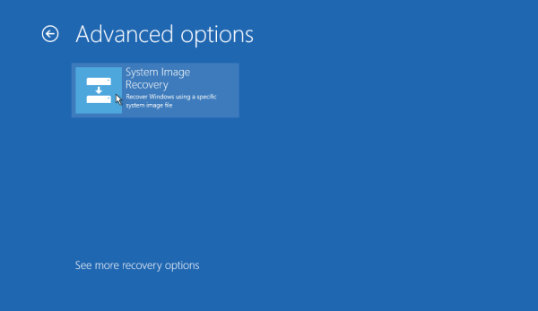

Restoring it from the image file may be your only option. Make sure your backup media is available. If you still can, boot up your PC.
- In Windows 10, go to Settings > Update & Security > Recovery. In the Advanced start-up section on the right, click the Restart now button under Advanced start-up. Windows 11 users should open Settings > System > Recovery and then click the Restart now button next to Advanced start-up.
- At the Choose an option window, go to Troubleshoot > Advanced Options > System Image Recovery > See more recovery options. Select System Image Recovery. From there, follow the prompts to restore your image file.
- If Windows won't boot, start up your PC with the system repair disc. You should be taken to the Choose an option window, where you can follow the same steps to restore Windows to a previous and (hopefully healthy) state.

Internal Assessment Criteria and Weight

- IAC0701 Recovery processes are identified and application is described.

SECTION 8: KM-06-KT-08 : Security fundamentals
Learning Outcome
- KT0801 Business continuity,
- KT0802 Disaster recovery planning,
- KT0803 Application development security,
- KT0804 Access control,
- KT0805 Information security governance,
- KT0806 Risk management,
- KT0807 Operation security,
- KT0808 Physical security,
- KT0809 Network security

- KT0801 Business continuity,
What is a Business Continuity Application?
A business continuity application is software used to help develop, manage or implement an organization’s business continuity plan and maintain its operations during a crisis or other unexpected disruption.
Business continuity application software tends to fall under one of two general categories. The first are applications that help an organization analyse its risks in various crisis scenarios and then develop a business continuity plan (BCP) to minimize operational disruptions. Examples in this category include software that can help analyse and estimate the real costs and other impacts of an outage to a particular business function. Applications in this category are often known as “business continuity management applications.”
The second are applications that an organization uses to implement various facets of its BCP and manage its operations during a crisis. A data backup and recovery tool is one example of a business continuity application in this latter category. These are sometimes known as “business continuity solutions.” In some cases, these two categories work together as part of an integrated solution.

- KT0802 Disaster recovery planning,
What is a disaster recovery plan?
Organizations of all sizes generate and manage massive amounts of data, much of it mission critical. The impact of corruption or data loss from human error, hardware failure, malware, or hacking can be substantial. Therefore, it is essential to create a disaster recovery plan for the restoration of business data from a data backup image.
It is most effective to develop an information technology (IT) disaster recovery plan in conjunction with the business continuity plan (BCP). A business continuity plan is a complete organizational plan that consists of five components:

1. Business resumption plan
2. Occupant emergency plan
3. Continuity of operations plan
4. Incident management plan (IMP)
5. Disaster recovery plan
Generally, components one through three do not touch upon IT infrastructure at all. The incident management plan typically establishes procedures and a structure to address cyber attacks against IT systems during normal times, so it does not deal with the IT infrastructure during disaster recovery. For this reason, the disaster recovery plan is the only component of the BCP of interest to IT.
Among the first steps in developing such a strategy is business impact analysis, during which the team should develop IT priorities and recovery time objectives. The team should time technology recovery strategies for restoring applications, hardware, and data to meet business recovery needs.
Every situation is unique and there is no single correct way to develop a disaster recovery plan. However, there are three principal goals of disaster recovery that form the core of most DRPs:

- prevention, including proper backups, generators, and surge protectors
- detection of new potential threats, a natural byproduct of routine inspections
- correction, which might include holding a “lessons learned” brainstorming session and securing proper insurance policies

- KT0803 Application development security,
Application security definition
Application security is the process of developing, adding, and testing security features within applications to prevent security vulnerabilities against threats such as unauthorized access and modification.

Why application security is important
Application security is important because today’s applications are often available over various networks and connected to the cloud, increasing vulnerabilities to security threats and breaches. There is increasing pressure and incentive to not only ensure security at the network level but also within applications themselves. One reason for this is because hackers are going after apps with their attacks more today than in the past. Application security testing can reveal weaknesses at the application level, helping to prevent these attacks.

Types of application security
Different types of application security features include authentication, authorization, encryption, logging, and application security testing. Developers can also code applications to reduce security vulnerabilities.
- Authentication: When software developers build procedures into an application to ensure that only authorized users gain access to it. Authentication procedures ensure that a user is who they say they are. This can be accomplished by requiring the user to provide a user name and password when logging in to an application. Multi-factor authentication requires more than one form of authentication—the factors might include something you know (a password), something you have (a mobile device), and something you are (a thumb print or facial recognition).
- Authorization: After a user has been authenticated, the user may be authorized to access and use the application. The system can validate that a user has permission to access the application by comparing the user’s identity with a list of authorized users. Authentication must happen before authorization so that the application matches only validated user credentials to the authorized user list.
- Encryption: After a user has been authenticated and is using the application, other security measures can protect sensitive data from being seen or even used by a cybercriminal. In cloud-based applications, where traffic containing sensitive data travels between the end user and the cloud, that traffic can be encrypted to keep the data safe.
- Logging: If there is a security breach in an application, logging can help identify who got access to the data and how. Application log files provide a time-stamped record of which aspects of the application were accessed and by whom.
- Application security testing: A necessary process to ensure that all of these security controls work properly.

- KT0804 Access control,
Access control is a data security process that enables organizations to manage who is authorized to access corporate data and resources. Secure access control uses policies that verify users are who they claim to be and ensures appropriate control access levels are granted to users.
Implementing access control is a crucial component of web application security, ensuring only the right users have the right level of access to the right resources. The process is critical to helping organizations avoid data breaches and fighting attack vectors, such as a buffer overflow attack, KRACK attack, on-path attack, or phishing attack.

What Are the Components of Access Control?
Access control is managed through several components:
Authentication
Authentication is the initial process of establishing the identity of a user. For example, when a user signs in to their email service or online banking account with a username and password combination, their identity has been authenticated. However, authentication alone is not sufficient to protect organizations’ data.

Authorization
Authorization adds an extra layer of security to the authentication process. It specifies access rights and privileges to resources to determine whether the user should be granted access to data or make a specific transaction.
For example, an email service or online bank account can require users to provide two-factor authentication (2FA), which is typically a combination of something they know (such as a password), something they possess (such as a token), or something they are (like a biometric verification). This information can also be verified through a 2FA mobile app or a thumbprint scan on a smartphone.
Access
Once a user has completed the authentication and authorization steps, their identity will be verified. This grants them access to the resource they are attempting to log in to.
Manage
Organizations can manage their access control system by adding and removing the authentication and authorization of their users and systems. Managing these systems can become complex in modern IT environments that comprise cloud services and on-premises systems.
Audit
Organizations can enforce the principle of least privilege through the access control audit process. This enables them to gather data around user activity and analyse that information to discover potential access violations.
- KT0805 Information security governance,
IT security governance is the system by which an organization directs and controls IT security (adapted from ISO 38500). IT security governance should not be confused with IT security management. IT security management is concerned with making decisions to mitigate risks; governance determines who is authorized to make decisions. Governance specifies the accountability framework and provides oversight to ensure that risks are adequately mitigated, while management ensures that controls are implemented to mitigate risks. Management recommends security strategies. Governance ensures that security strategies are aligned with business objectives and consistent with regulations.
Why is information security governance important?
Information security governance ensures that an organization has the correct information structure, leadership, and guidance. Governance helps ensure that a company has the proper administrative controls to mitigate risk. Risk analysis helps ensure that an organization properly identifies, analyses, and mitigates risk.
- KT0806 Risk management,
Information security risk management, or ISRM, is the process of managing risks associated with the use of information technology. It involves identifying, assessing, and treating risks to the confidentiality, integrity, and availability of an organization’s assets. The end goal of this process is to treat risks in accordance with an organization’s overall risk tolerance. Businesses shouldn’t expect to eliminate all risks; rather, they should seek to identify and achieve an acceptable risk level for their organization.
- Identify assets: What data, systems, or other assets would be considered your organization’s “crown jewels”? For example, which assets would have the most significant impact on your organization if their confidentiality, integrity or availability were compromised? It’s not hard to see why the confidentiality of data like social security numbers and intellectual property is important. But what about integrity? For example, if a business falls under Sarbanes-Oxley (SOX) regulatory requirements, a minor integrity problem in financial reporting data could result in an enormous cost. Or, if an organization is an online music streaming service and the availability of music files is compromised, then they could lose subscribers.
- Identify vulnerabilities: What system-level or software vulnerabilities are putting the confidentiality, integrity, and availability of the assets at risk? What weaknesses or deficiencies in organizational processes could result in information being compromised?
- Identify threats: What are some of the potential causes of assets or information becoming compromised? For example, is your organization’s data centre located in a region where environmental threats, like tornadoes and floods, are more prevalent? Are industry peers being actively targeted and hacked by a known crime syndicate, hacktivist group, or government-sponsored entity? Threat modelling is an important activity that helps add context by tying risks to known threats and the different ways those threats can cause risks to become realized via exploiting vulnerabilities.
- Identify controls: What do you already have in place to protect identified assets? A control directly addresses an identified vulnerability or threat by either completely fixing it (remediation) or lessening the likelihood and/or impact of a risk being realized (mitigation). For example, if you’ve identified a risk of terminated users continuing to have access to a specific application, then a control could be a process that automatically removes users from that application upon their termination. A compensating control is a “safety net” control that indirectly addresses a risk. Continuing with the same example above, a compensating control may be a quarterly access review process. During this review, the application user list is cross-referenced with the company’s user directory and termination lists to find users with unwarranted access and then reactively remove that unauthorized access when it’s found.
- KT0807 Operation security,
What is Operational Security?
Operational security (OPSEC) is a security and risk management process that prevents sensitive information from getting into the wrong hands.
Another OPSEC meaning is a process that identifies seemingly innocuous actions that could inadvertently reveal critical or sensitive data to a cybercriminal. OPSEC is both a process and a strategy, and it encourages IT and security managers to view their operations and systems from the perspective of a potential attacker. It includes analytical activities and processes like behaviour monitoring, social media monitoring, and security best practice.

A crucial piece of what is OPSEC is the use of risk management to discover potential threats and vulnerabilities in organizations’ processes, the way they operate, and the software and hardware their employees use. Looking at systems and operations from a third party’s point of view enables OPSEC teams to discover issues they may have overlooked and can be crucial to implementing the appropriate countermeasures that will keep their most sensitive data secure.
The 5 Steps of Operational Security
There are five steps to OPSEC that allow organizations to secure their data processes.
Identify Sensitive Data
Understanding what data organizations have and the sensitive data they store on their systems is a crucial first step to OPSEC security. This includes identifying information such as customer details, credit card data, employee details, financial statements, intellectual property, and product research. It is vital for organizations to focus their resources on protecting this critical data.
Identify Possible Threats
With sensitive information identified, organizations then need to determine the potential threats presented to this data. This includes third parties that may want to steal the data, competitors that could gain an advantage by stealing information, and insider threats or malicious insiders like disgruntled workers or negligent employees
Analyse the Vulnerabilities
Organizations then need to analyse the potential vulnerabilities in their security defenses that could provide an opportunity for the threats to materialize. This involves assessing the processes and technology solutions that safeguard their data and identifying loopholes or weaknesses that attackers could potentially exploit.
What is the Threat Level?
Each identified vulnerability then has to have a level of threat attributed to it. The vulnerabilities should be ranked based on the likelihood of attackers targeting them, the level of damage caused if they are exploited, and the amount of time and work required to mitigate and repair the damage. The more damage that could be inflicted and the higher the chances of an attack occurring, the more resources and priority that organizations should place in mitigating the risk.
Devise a Plan To Mitigate the Threats
This information provides organizations with everything they need to devise a plan to mitigate the threats identified. The final step in OPSEC is putting countermeasures in place to eliminate threats and mitigate cyber risks. These typically include updating hardware, creating policies around safeguarding sensitive data, and providing employee training on security best practice and corporate data policies.
- KT0808 Physical security,
Protecting important data, confidential information, networks, software, equipment, facilities, company’s assets, and personnel is what physical security is about. There are two factors by which the security can be affected. First attack by nature like a flood, fire, power fluctuation, etc. Though the information will not be misused, it is very hard to retrieve it and may cause permanent loss of data. Second is attack by the malicious party, which includes terrorism, vandalism, and theft. All the organization faces different kinds of physical security threats.
Physical security is very important, but it is usually overlooked by most organizations. It is necessary if you do not want anyone to snatch away your information or destroy it, in case of natural calamity. The reason could be anything, the attacker doing it for personal gain, financial gain, for seeking revenge or you were the vulnerable target available. If this security is not maintained properly, all the safety measures will be useless once the attacker gets through by gaining physical access. Though physical security is proving to be challenging than previous decades as there are more sensitive devices available (like USB drives, laptops, smartphones, tablets, etc.) that enables the stealing of data easy and smooth.
- KT0809 Network security
What is Network Security?
Network Security protects your network and data from breaches, intrusions and other threats. This is a vast and overarching term that describes hardware and software solutions as well as processes or rules and configurations relating to network use, accessibility, and overall threat protection.

Network Security involves access control, virus and antivirus software, application security, network analytics, types of network-related security (endpoint, web, wireless), firewalls, VPN encryption and more.
Types of Network Security Protections
Firewall
Firewalls control incoming and outgoing traffic on networks, with predetermined security rules. Firewalls keep out unfriendly traffic and is a necessary part of daily computing. Network Security relies heavily on Firewalls, and especially Next Generation Firewalls, which focus on blocking malware and application-layer attacks.
Network Segmentation
Network segmentation defines boundaries between network segments where assets within the group have a common function, risk or role within an organization. For instance, the perimeter gateway segments a company network from the Internet. Potential threats outside the network are prevented, ensuring that an organization’s sensitive data remains inside. Organizations can go further by defining additional internal boundaries within their network, which can provide improved security and access control.

Internal Assessment Criteria and Weight
- IAC0801 Typical security risks are listed.
- IAC0802 The importance of counter measures is justified.

SECTION 9: KM-06-KT-09 : IT Foundation and Cloud Programming
Learning Outcome
- KT0901 Programming languages
- KT0902 Operating systems
KT0903 Open source
- KT0904 Tools for a cloud environment (for configuration and management) tools for debugging, login and monitoring.
- KT0905 Tools for image.
- KT0906 Familiarity with Office tools
- KT0907 Introduction to programming for the cloud
- KT0908 HTML5 and CSS3 Overview
- KT0909 JavaScript Programming for Web Applications
- KT0910 HTML5 Elements
- KT0911 GitHub

- KT0901 Programming languages
What are the 4 types of programming language?
- Procedural Programming Language.
- Functional Programming Language.
- Scripting Programming Language.
- Logic Programming Language.
- Object-Oriented Programming Language.

- KT0902 Operating systems
What is an operating system?
An operating system (OS) is the program that, after being initially loaded into the computer by a boot program, manages all of the other application programs in a computer. The application programs make use of the operating system by making requests for services through a defined application program interface (API). In addition, users can interact directly with the operating system through a user interface, such as a command-line interface (CLI) or a graphical UI (GUI).
Why use an operating system?
An operating system brings powerful benefits to computer software and software development. Without an operating system, every application would need to include its own UI, as well as the comprehensive code needed to handle all low-level functionality of the underlying computer, such as disk storage, network interfaces and so on. Considering the vast array of underlying hardware available, this would vastly bloat the size of every application and make software development impractical.
Instead, many common tasks, such as sending a network packet or displaying text on a standard output device, such as a display, can be offloaded to system software that serves as an intermediary between the applications and the hardware. The system software provides a consistent and repeatable way for applications to interact with the hardware without the applications needing to know any details about the hardware.
As long as each application accesses the same resources and services in the same way, that system software -- the operating system -- can service almost any number of applications. This vastly reduces the amount of time and coding required to develop and debug an application, while ensuring that users can control, configure and manage the system hardware through a common and well-understood interface.

- KT0903 Open source
What is open-source software?
Open-source software is software with source code that anyone can inspect, modify, and enhance.

"Source code" is the part of software that most computer users don't ever see; it's the code computer programmers can manipulate to change how a piece of software—a "program" or "application"—works. Programmers who have access to a computer program's source code can improve that program by adding features to it or fixing parts that don't always work correctly.

- KT0904 Tools for a cloud environment (for configuration and management) tools for debugging, login and monitoring.
Why use configuration management tools?
Configuration management tools enable changes and deployments to be faster, repeatable, scalable, predictable, and able to maintain the desired state, which brings controlled assets into an expected state.
Some advantages of using configuration management tools include:
- Adherence to coding conventions that make it easier to navigate code
- Idempotency, which means that the end state remains the same, no matter how many times the code is executed
- Distribution design to improve managing large numbers of remote servers
Some configuration management tools use a pull model, in which an agent installed on the servers runs periodically to pull the latest definitions from a central repository and apply them to the server. Other tools use a push model, where a central server triggers updates to managed servers.

What’s the Difference? Logging vs Monitoring
Logging is used as both a verb and a noun, referring either to the practice of logging errors and changes or to the application logs that are collected. The purpose of logging is to create an ongoing record of application events. Log files can be used to review any event within a system, including failures and state transformations. Consequently, log messages can provide valuable information to help pinpoint the cause of performance problems. Log data can help DevOps teams troubleshoot issues by identifying which changes resulted in error reporting, but is only as valuable as the information it contains.
Log management also serves other purposes, such as creating written records for audit and compliance purposes, identifying trends over time, and securing sensitive information. Logging performs a valuable role in applications of all sizes, but should be implemented thoughtfully. Avoid storing, transferring, or evaluating extraneous information by prioritizing actionable items. Logging too much data can create a drain on resources, both in terms of cost and time. A good logging strategy generally provides two types of data: structured data for machines and data that alerts system administrators to a potential problem.
Monitoring is an umbrella term that can include many facets of system evaluation, but in this context, we're referring to application performance monitoring (APM). APM is the process of instrumenting an application to collect, aggregate and analyse metrics to better evaluate the use of the system by gauging availability, response time, memory usage, bandwidth, and CPU time consumption.
Monitoring systems rely on metrics to alert IT teams to operating anomalies across applications and cloud services. Ideally, teams would implement instrumentation and monitoring on all systems.

- KT0905 Tools for image.
Image Design Tools
- Canva.
- PicMonkey.
- Stencil.
- BeFunky.
- Venngage.
- Infogr.am.
- Piktochart.
- Visme.

- KT0906 Familiarity with Office tools
Office Tools
Office Tools are a type of application software. They help the users to perform office-related tasks easily and efficiently. Therefore, these tools help to create, manage, and manipulate large amounts of data and documents. Moreover, they help create presentations, reports, databases, etc. Hence, users can perform such tasks repeatedly with less time and effort. These tools include software such as word processors, presentation tools, spreadsheets database systems, email tools, etc.
Types of Office Tools and their Examples
1. Word Processor Tool
This software deals with text documents. It helps to create, format, manipulate, and save text files. Besides, the software can either run on the hardware as a desktop application such as Microsoft word. Or on the other hand, it can also be cloud-based such as google docs.
- MS-Word
- WordPad
- WordPerfect
- Google Docs
- LibreOffice Writer
- office tools

2. Presentation Tool
This tool helps the user to break the information into small parts called slides. Slides are basically small parts of a particular topic arranged on different pages. Moreover, a series of these slides representing an idea to the audience is called presentation. Besides, this tool allows the user to present these presentations using the slideshow feature. Furthermore, the slides can contain pictures, audios, videos, graphs, tables, etc.
- MS-PowerPoint
- Lotus Freelance
- Google Slides
- LibreOffice Impress
3. Spreadsheet Tool
This software contains the data in the form of rows and columns. The intersection of a row and column is a cell. They store the data and have various formulas which in turn helps to analyse, calculate, and draw conclusions from data. The business and financial sectors use this software more often. They also contain additional features like graphs, charts, 3D graphs, tables, etc. for effective results. Report presentation is thus quite easy considering these results.
- MS-Excel
- Google Sheets
- LibreOffice Calc
- Gnumeric
- office tools
4. Database Management Systems
A database is a collection of related data or information in an organized form. A database management system is a tool that is used to store, search, extract, or delete information from a database. Moreover, we use them so that the operations which we perform on the database, are in an organized manner and safe.
Some database management tools help in handling records on the system like phone numbers, mailing lists, catalogues, etc. Examples are MS Access, Filemaker, dBASE, etc.
- MySQL
- PostgreSQL
- Oracle Database
- Microsoft Access
- MS-Access
- FoxPro

- KT0907 Introduction to programming for the cloud
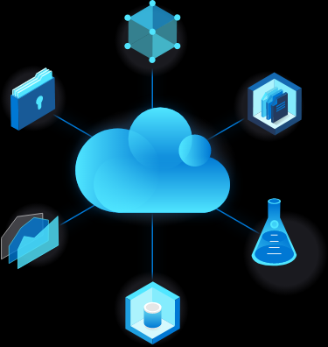

Simply put, cloud computing is the delivery of computing services—including servers, storage, databases, networking, software, analytics, and intelligence—over the Internet (“the cloud”) to offer faster innovation, flexible resources, and economies of scale. You typically pay only for cloud services you use, helping lower your operating costs, run your infrastructure more efficiently and scale as your business needs change.

- KT0908 HTML5 and CSS3 Overview
What is HTML5 and its uses?
HTML5 is a markup language used for structuring and presenting content on the World Wide Web. It is the fifth and final major HTML version that is a World Wide Web Consortium (W3C) recommendation. The current specification is known as the HTML Living Standard.
What is CSS3?
Cascading Style Sheets Level 3 (CSS3) is the iteration of the CSS standard used in the styling and formatting of Web pages. CSS3 incorporates the CSS2 standard with some changes and improvements. A key change is the division of standard into separate modules, which makes it easier to learn and understand.
Advanced Features of HTML5 and CSS3
- Editing content within the elements. You can edit content within an element by using an HTML attribute called content editable. ...
- Form attribute required. ...
- Regular expressions. ...
- Figure tag. ...
- SVG element. ...
- Web fonts. ...
- Gradient. ...
- Animation and Transition.

- KT0909 JavaScript Programming for Web Applications
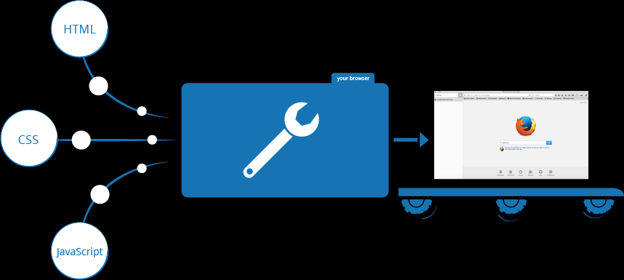

JavaScript is a scripting language that enables you to create dynamically updating content, control multimedia, animate images, and pretty much everything else. (Okay, not everything, but it is amazing what you can achieve with a few lines of JavaScript code.)
What is JavaScript doing on your page?
Here we'll actually start looking at some code, and while doing so, explore what actually happens when you run some JavaScript in your page.
Let's briefly recap the story of what happens when you load a web page in a browser (first talked about in our How CSS works article). When you load a web page in your browser, you are running your code (the HTML, CSS, and JavaScript) inside an execution environment (the browser tab). This is like a factory that takes in raw materials (the code) and outputs a product (the web page).

- KT0910 HTML5 Elements
What are the basic HTML elements?
- A text header, denoted using the <h1> , <h2> , <h3> , <h4> , <h5> , <h6> tags.
- A paragraph, denoted using the <p> tag.
- A horizontal ruler, denoted using the <hr> tag.
- A link, denoted using the <a> (anchor) tag.

- KT0911 GitHub
What is GitHub used for?
GitHub is a code hosting platform for version control and collaboration. It lets you and others work together on projects from anywhere. This tutorial teaches you GitHub essentials like repositories, branches, commits, and pull requests.

Internal Assessment Criteria and Weight

• IAC0901

SECTION 10: KM-06-KT-10 : Key features of cloud platforms (at least 3 vendor specific platforms)
Learning Outcome
- KT1001 Platform specific services
- KT1002 Core resources available on the platform
- KT1003 Core solutions and management tools on the platform
- KT1004 General security and network security features
- KT1005 Identity, governance, privacy, and compliance features
- KT1006 Cost and Service Level Agreements management tools
- KT1001 Platform specific services
Platform-specifics allow you to consume functionality that's only available on a specific platform, without implementing custom renderers or effects.
Creating platform-specifics
Vendors can create their own platform-specifics with Effects. An Effect provides the specific functionality, which is then exposed through a platform-specific. The result is an Effect that can be more easily consumed through XAML, and through a fluent code API.
The process for creating a platform-specific is as follows:
- Implement the specific functionality as an Effect. For more information, see Creating an Effect.
- Create a platform-specific class that will expose the Effect. For more information, see Creating a Platform-Specific Class.
- In the platform-specific class, implement an attached property to allow the platform-specific to be consumed through XAML. For more information, see Adding an Attached Property.
- In the platform-specific class, implement extension methods to allow the platform-specific to be consumed through a fluent code API. For more information, see Adding Extension Methods.
- Modify the Effect implementation so that the Effect is only applied if the platform-specific has been invoked on the same platform as the Effect. For more information, see Creating the Effect.
The result of exposing an Effect as a platform-specific is that the Effect can be more easily consumed through XAML and through a fluent code API.
- KT1002 Core resources available on the platform
What are the resources in cloud?
Cloud computing is the delivery of computing resources — including storage, processing power, databases, networking, analytics, artificial intelligence, and software applications — over the internet (the cloud).
How does cloud computing work?
Rather than owning their own computing infrastructure or data centres, companies can rent access to anything from applications to storage from a cloud service provider.
One benefit of using cloud-computing services is that firms can avoid the upfront cost and complexity of owning and maintaining their own IT infrastructure, and instead simply pay for what they use, when they use it.

What cloud-computing services are available?
Cloud-computing services cover a vast range of options now, from the basics of storage, networking and processing power, through to natural language processing and artificial intelligence as well as standard office applications. Pretty much any service that doesn't require you to be physically close to the computer hardware that you are using can now be delivered via the cloud – even quantum computing.

What are examples of cloud computing?
Cloud computing underpins a vast number of services. That includes consumer services like Gmail or the cloud backup of the photos on your smartphone, though to the services that allow large enterprises to host all their data and run all of their applications in the cloud. For example, Netflix relies on cloud-computing services to run its its video-streaming service and its other business systems, too.
Cloud computing is becoming the default option for many apps: software vendors are increasingly offering their applications as services over the internet rather than standalone products as they try to switch to a subscription model. However, there are potential downsides to cloud computing, in that it can also introduce new costs and new risks for companies using it.

- KT1003 Core solutions and management tools on the platform
What is cloud management tools?
Cloud management tools are those that enable organizations to manage their multi-cloud (both public clouds and those on-premise) resources and services. These tools can be purchased and operated by: One central organization. Numerous lines of business.
Here are six key capabilities you should look for in a cloud management platform:
- Simplify Complexity. One of the main reasons that IaaS has been such a huge hit is flexibility. ...
- Manage Multiple Clouds. ...
- Build for the Future. ...
- Support the Application Lifecycle. ...
- Automation: Set It and Forget It. ...
- Manage and Control Costs.
What are cloud management tools?
Cloud management tools are those that enable organizations to manage their multi-cloud (both public clouds and those on-premise) resources and services. These tools can be purchased and operated by:

- One central organization
- Numerous lines of business
Tools can also be deployed as a SaaS product or on-premises. These tools serve nearly limitless functions and cover a variety of categories such as:
- Resource and capacity management
- Security
- Compliance
- Big data analytics
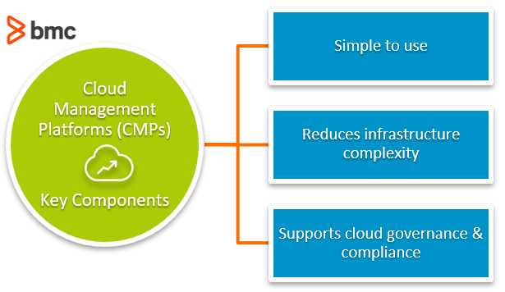
Features of cloud management tools
There are many factors to consider when trying to decide how to choose the right cloud management tools, including:
- Resource management
- Performance monitoring
- Scalability
- Automation and provisioning
- Cross-platform interoperability
- Compliance and governance
- Reporting

- KT1004 General security and network security features
What is Network Security?
Network Security protects your network and data from breaches, intrusions and other threats. This is a vast and overarching term that describes hardware and software solutions as well as processes or rules and configurations relating to network use, accessibility, and overall threat protection.
Network Security Software Features and Capabilities
- Firewalls.
- Malware detection.
- Sandboxing.
- Network mapping and visibility.
- Endpoint security.
- Network Access Control.
- Traffic analysis.
- KT1005 Identity, governance, privacy, and compliance features
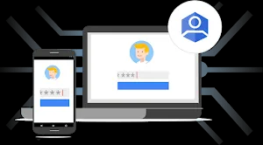

What is an identity platform?
Identity Platform is a customer identity and access management (CIAM) platform that helps organizations add identity and access management functionality to their applications, protect user accounts, and scale with confidence on Google Cloud.
Platform governance is an approach necessitating an understanding of technical systems (platforms) and an appreciation for the inherently global arena within which these platform companies' function.

- KT1006 Cost and Service Level Agreements management tools
What is an example of an SLA?
A service level agreement (SLA) is an agreement between an IT Service provider and a customer. For instance, you are a customer of a bank and the bank provides services to you.
What are the 4 aspects of service level agreement?
The main elements of a good SLA.
- Overall objectives. The SLA should set out the overall objectives for the services to be provided.
- Description of the Services. The SLA should include a detailed description of the services.
- Performance Standards.
- Compensation/Service Credits.
- Critical Failure.

Internal Assessment Criteria and Weight

- IAC1001 Key features of cloud platforms for at least 3 vendor specific platforms are identified and described in terms of functions and application.

Good Luck!

